Barony of Krae Glas – Meeting Minutes [21/04/2026]
Time: opened by Rúnfríðr Keiliselgr at 7:41pm, closed at 8:55pm.
Date: 21/04/2026
Attendance:
Seneschal | Rúnfríðr Keiliselgr  (Rachel Thorpe-Jones) | Present
Deputy Seneschal | Maria Giovanna Guarnieri  (Alyssa Jefferyes) | Present
Reeve | Finn of St Monica  (Finn Mac Eoin) | Apologies
Deputy (outgoing) Reeve | Elizabet Hunter  (Janet Coath) | Absent
Knight Marshal | Cormac Lenihan  (Conrad Leviston) | Present
Rapier Marshal | Elef á Suðrmannalandi (Lily Collins) | Apologies
Captain of Archers | Maude atte Weylete (Michelle Kurrle) | Absent
A&S Officer | Emelye Ryder  (Natalie Szabo) | Absent
Herald | Ailbhe éccnaid  (Ebony Biar) | Absent
Deputy Herald | Tassilon Fetherstonhaughe  (Patrick Corby) | Present
Chatelaine | Bermund Wandelber (Craig Chan) | Present
Chronicler and Social Media Officer | Julia of the Ravens  (Julia Jamieson) | Present
Deputy Chronicler | Joanna of Braidwood (Joanna Thorpe-Jones) | Present
Webminister | Robert de Mar  (Robert Jamieson) | Present
Baron | Jon Dai of the Lane  (Stephen Davis) | Present
Baroness | Margie of Glen More  (Margie Henley) | Present
St Monica Seneschal | Theodwin Vriunt  (Zachary Bessemer) | Excused

Populace attending: Baron Airdin Mac Dara (Warren McArdle), Lady Sorcha ingen ui Chainnigh,

Minutes: taken by Giovanna. Motions are highlighted in blue. Action points are in yellow.

Previous minutes:
The 17/03/2026 minutes were approved. Moved by Margie, seconded by Bermund. Sir Jon abstained.

Officer appointments and vacancies since last month:
- Rúna: Captain of Archers is open and I am advertising for Constable again, which has been vacant for a year.
  - Airdin: Róisin can help with handover for the new Constable. She’s also happy to help on Thursdays and keep taking the money there.
  - Rúna: yes, she’s wonderful.

Event reports:
- Return of the Kraken Event Report (see Appendix 1)
  - Airdin: it’s done because I had a helper!
  - Rúna: it’s a ‘nothing burger of a report’ but we made a profit which is nice.
  - Jon: do we need to approve this?
    - Rúna: I like to approve things in Council because I like to give the opportunity for feedback.
  - Airdin: I liked that it was family friendly and that we had families turning up, specifically people we hadn’t seen in a while.
    - Rúna: Me too. I would love to have it again.
  - Approval: moved by Jon, seconded by Margie.
  - Jon: have we saved that form as a template?
    - Rúna: yes, I supply it as a form fillable PDF to event stewards. I noticed people were struggling last year with filling out forms and the PDF is easier for everyone.
    - Airdin: they’ve been Airdin proofed!

Upcoming events:
Regular events:
- Regular Thursday night training
  - Cormac: It hasn’t been super crowded – we missed one day for festival. It’s running regularly and people are generally comfortable that there will be at least something happening.
  - Airdin: we are sometimes getting up to nine people!
  - Cormac: the one change we have had this year is that fencing is more consistently running, which is good.
  - Cormac: there was talk of calligraphy, but that’s going to require sufficient numbers. If it goes forward, we will have the problem of lighting. I told people they should go old school and use candle light and ruin their eyes. Really commit to it!
  - Airdin: we might have lights outside, depending on if we can negotiate a system with the Rovers.
- Archery
  - Sorcha: Maude and I were the main Krae Glas attendees and Her Excellency came for the last hour and a half. Our three other attendees were from Stormhold. We expected it would be a smaller group because it happened so soon after Rowany, so the numbers weren’t bad given the timing.
  - Airdin: we have use of the rear storeroom at the hall behind the double doors. Someone should tell Maude that we could put the archery things there for easy access.

Other events
- Royal Brunch/Crafthall (Jon and Margie stewarding – May 10th)
  - Jon: I have six bookings - Margie, myself, the King and Queen and two people from Innilgard.
    - Rúna: who from Innilgard?
    - Jon: doesn’t matter.
    - Airdin: you’re coming anyway.
    - Rúna: I was just wondering if some people I know from Innilgard were coming.
    - Margie: ‘if those Innilgardians aren’t your friends, you can make them your friends’.
    - Rúna: that sounds like I’m trying to threaten them?
  - Jon: please book!
    - Airdin: link? (Rúna: email the B&B to book.)
  - Julia: I have made the page but haven’t gotten the chance to start promoting. It will be in the monthly post.
  - Airdin: I have confirmation from the Rovers that the change of date for Crafthall to that Sunday is good, so we won’t pay more.

- Renfaire (Rúna and Leif stewarding – May 16th to 17th, see Appendix 2)
  - Rúna: Per Airdin’s suggestion, Baron Leif has joined the team and he has been very helpful. Anyone who says they can fight is pretty much going because we need more fighters, but we’re still making decisions on which A&S people can go. Any questions can be directed to Leif or I.
  - Rúna: Although it’s not been historically done in Melbourne for demos, I just found out that we still need to do an event proposal with the SCA, so I’ve written up one that we need Council to approve.
  - Margie: do you need us to bring things like tables and covers for the event?
    - Rúna: Baron Leif says we should have received an information pack including things like what tables the event organisers are providing, which we haven’t yet. Until we know what they’re providing, we can’t work out what we need. I’m emailing Konga about it tonight.
    - Jon: we need to know by the end of the week.
    - Margie: How are we coordinating transport of supplies and infrastructure?
    - Rúna: we need to figure out what needs to be brought over first. I will then chat to Baron Leif.
    - Margie: have they given us an idea of space?
    - Rúna: yes, I have asked for 30x30m per Sir Jon’s suggestion in the Victorian Baronial executive chat a while ago.
    - Margie: at some stage and not the week before we need to know what we’re taking.
    - Rúna: yes, we will let you know.
  - Rúna: the Reeve has provisionally approved this event proposal. The event is at the Yarra Valley Racecourse. Entry for us is free unless you’re a non-member in which case you will need to pay insurance. The current plan is to split expenditure 50/50 with Stormhold but we are waiting for SH to approve that at their Council tomorrow. The money for printing seems like a ridiculous budget, but the question was whether we wanted to include flyers for upcoming events etc.
    - Margie: why don’t we use a QR code?
    - Julia: we have one that links to our link tree. I can add SH.
    - Margie: I’m wondering if that is a better choice than business cards as it can save some trees.
    - Rob: yeah, last time QR codes were everywhere
  - Jon: I wouldn’t worry about tokens. I can’t say I’ve ever given out roses or tokens at a demo.
    - Rúna: we were considering doing a rose tourney at one point.
  - Margie: does the event form need anything if people are staying overnight?
    - Rúna: good point. I will note that in the form. We don’t know the overnight situation currently, but we know some people have volunteered to stay overnight.
    - Margie: the priority should be people who have things of value.
    - Rúna: people with period looking tents also get priority.
  - Jon: Depending on who’s coming is a cooking display feasible? It will take a lot up of the 30x30m.
    - Rúna: we have a group chat on it with Miriam, Waldo, eleanora and some others.
    - Margie: oh, they’re an excellent group. This will work.
  - Jon: I don’t think we need to pay kingdom levy. The only other paperwork we need is a sign in sheet. (Rúna: correct. If it’s free entry, no levy is needed.)
  - Airdin: it sounds good and like you’ve got some definite progress. Lots of promotional stuff is a good idea.
  - Rúna: to get back to the numbers, what do I need to change for Council to be happy with this?
    - Jon: I would just say a contingency budget of $500/600. Anything else is irrelevant.
    - Margie: Remember, $600 is actually $300 because shared with SH.
    - Rúna: sounds good to me!
  - Margie: does anything need to be added on the form in regards to the expectation not to wander off?
    - Rúna: it’s been made clear that there is an expectation to stay at the stall at the top.
    - Airdin: I’m sure there will be some time to see things
  - Approval: moved by Airdin, seconded by Sir Jon.
  - Rúna: any other questions about Renfair I can answer while we’re here?
    - Jon: nah, I’ll just message Leif for what we need to bring.
- Midwinter Hunt (Sorcha stewarding – June 21st)
  - Sorcha: I talked to Sharr and Her Excellency about target availability and set up for the roving round. I intend to get a map drawn up. I’ve had three people express interest in being the final target, which I think will work well because we won’t necessarily be able to run this like a normal line. It will be good to rotate people in case the deer want a go at shooting.
  - Sorcha: I have been told we will have access to a rubber boar and rabbit and that the twins might have a rabbit target?
    - Jon: I have two guinea fowl and a small deer and potentially three or four pigeons.
    - Margie: pigeons can be attached to a tree!
    - Jon: yes, they come with pegs. I believe there are rabbits in the storeroom.
    - Sorcha: yes, Maude sent me a photo of what we had. The target marshal and I want some of them to help create the atmosphere.
  - Margie: there is the possibility of a humanoid mushroom to be hunted by vegetarians. Can I suggest anyone who has items send a photo to Sorcha so she knows what she’s working with
    - Jon: yeah, I can do that.
    - Margie: can we also get an inventory on what arrows and bows we have?
  - Sorcha: another thing we need to think of is that we will need to check the arrows haven’t been damaged before the deer section, since I’m limiting it to combat arrows on site.
  - Sorcha: Should the foraging happen before or after the hunt? Pros of having it before is that you can relax whilst you have a lunch, pros to having it after is that the people previously shooting could forage and people previously shooting can go set up the feast. Any opinions?
    - Margie: could we do it during arrow inspection
    - [Jon: I have to go as the base alarm is going off.]
  - Sorcha: For tokens I found calico to save me money.
    - Airdin: can you buy premade calico bags?
    - Sorcha: yeah, but the size can get excessive and it can be expensive.
  - Margie: what is the cap on numbers for the event?
    - Sorcha: not sure. Airdin, what’s the cap for fire safety?
    - Airdin: I don’t know.
    - Margie: But how many can we fit in the hall with tables and chairs?
    - Airdin: I think our biggest event was 70?
    - Margie: we don’t want to book more than we can accommodate. We can ask someone who is going to come on Thursday to volunteer to do a count for us. Some of the table space won’t be available because we will need to dedicate them to food prep. Additionally, if a lot of people are coming we will need to rely on slow cookers.
    - Airdin: need to watch out we don’t overload the electricity.
    - Sorcha: could we use the A&S room? (Margie: logistically not a good idea.)
    - Margie: we might only get 40 bookings, which is manageable.
  - Airdin: could you see how many people came to the welcome to the hearth event 2023?
    - Julia: It was 5th October 2023. I have the date in front of me because I like to be organised like that.
    - Rúna: Dropbox mysteriously doesn’t have the numbers for that.
  - Airdin: I have sent off a request to the Rovers about using the firepit but haven’t heard back.
  - Airdin: Rovers have been having some pushback from scouts Victoria about what they can and can’t do. I believe they are allowed to repair but not renovate without approval. Scouts Victoria at the moment is disputing the Rovers on the financial aspects of the ramp.
    - Julia: can we petition the scouts?
    - Airdin: I will need to
    - Margie: we don’t want to come across to risky, or they might give us the boot.
  - Sorcha: I have advertising photos for deer spotting! Sharr does not like being identified in photos, so please don’t tag him.
    - Julia: Excellent!
- ICW (Rúna and Theo stewarding – July 17th to 20th)
  - Rúna: The College’s bid was submitted and approved by the other College Seneschals. The College will ask for marshals to help us later but would like to borrow cooking equipment and list fields from the Barony. Is Council happy to approve items to be borrowed?
  - Margie: do we have a list?
    - Rúna: we do not have a list yet. At the moment we are thinking cooking items, list fields and tabards. I can come back next month if you want a list. I don’t know if they can though, because as we know the college can’t set up a list field and might not know what they need without looking at what we have first.
    - Airdin: I taught you!
    - Margie: I would prefer a list to keep things consistent.
  - Rúna: Malleta [the Feast Steward] was going to photograph things as she takes them, but what kind of details are you looking for in advance?
    - Margie: 6 x cooking pots, 5 ladles etc because that’s the only way we can track these things.
    - Julia: the real issue is it being last minute, so if we can avoid that we’re golden.
    - Margie: if the list is made as the things are taken then that’s fine.
  - Airdin: the request is approved I think is what we are saying. Thank you for asking in advance.
  - Joanna: on the list of what is borrowed if you could put who is responsible from the college, I think that would be good.
  - Airdin: do you want a few of the old folk coming along and helping out with the event, for example the B&B?
    - Rúna: we probably will. We will need people who know about fighting for example. Volunteers are always accepted by message to me.

New General Business
Tile subscription (Airdin)
- Airdin: each set of keys has a little square on it so I can track it, which was handy when we needed to track down Maerwynn’s set. The subscription is about to be up. I’ve been paying for it since 2023. It’s about $50 per year. The Reeve said it could be reimbursed because it’s for the group and not personal. It is $48.99 per year. I also have some invoices for what I paid for it for the last couple of years.
  - Tassilon: promise it’s just for Krae Glas? Pinky swear? [paraphrased by the editor]
  - Airdin: pinky swear [paraphrased by the editor]
- Rúna: Finn has asked me to convey his support, whatever that means.
- Approved for $48.99 for another year of the subscription. Moved by Tassilon, seconded by Julia.
- Rúna: Council has authorised $48.99. The Reeve did not tell me about any back payments or retrospective reimbursements, so we will not approve that unless the Reeve is aware.
- Rúna: I'm going to close the meeting before Airdin does anything else bad.

Officers present declared nothing to discuss from officer reports. Included for reference.

Seneschal’s Report:
Lots more happening with events, which is always lovely to see. Approvals have happened on the Seneschal database for two events, the Kraken report is in, and I’ve been working with Baron Leif from Stormhold on Renfair. Thank you to Baron Airdin for the suggestion that we work together. More on that in the Renfair update.
I’m also stewarding ICW with the College Seneschal Lord Theodwin Vriunt. There will also be more on that later.
In terms of future events, our Baronial birthday is coming up. It will be our fifteenth. Do let me and or our Baronage know if you’re curious to take that on.
I’m hoping to work with our Webwright to re-locate and update the events section of our website, but that will take a backburner to event things as they come up.

April 2026 Chronicler/Social Media Officer/Recorder of Memories report: Chronicler report: Kingdom have approved appointment of Joanna as new Chronicler, awaiting official announcement from Kingdom. Joanna has made another great newsletter.
Social Media Officer report: Stats: Facebook is at 385 followers (-1 from last month). Insta is at 130 followers (+1 from last month). Average views & engagement on both Facebook & Instagram are lower again, but I've been posting a bit less as most people were away. Nothing to report as the recorder of memories.
In General: Thanks to Rúna's help, I have been making progress with my backlog & I am optimistic about getting caught up in the near future!

Airdin Hall update: The storeroom needs a spruce up and we can store some items in the rear storeroom (think Archery targets, or items we hardly use like the stocks etc.)
Krae Glas Reeve’s report for April 2026 council meeting
Account balances as at the end of March 2026 :
- Community Solutions One account $12,461.86
- Cash Reserve B account $0.01
- Total of $12,461.87
No cash reserve or floats are outstanding; Xero is fully reconciled to end of March and Dropbox is up to date with bank statements and sign in sheets.
The Event Report for the Return of the Kraken event has been provisionally accepted at the time of writing, and it should be fully accepted by the April 2026 council meeting.
Matters arising from the previous report: resolved: $5 from feb craft hall has been found, Return of the Kraken report has been submitted and provisionally accepted,; sign in sheet from 5th of Feb Thursday Training has been found
Unresolved: - We are out $30 from feb archery. [redacted]- I completely forgot about this and didn't get around to chasing any of them down.
April 2026 Webwright report :
Since last time, the backend of the website has been maintained with updates, work continues on the revamp of the main/home page. The Blue Strand continues to help improve search functions within the website and to help improve google SEO with its keywords. I am continuing to rotate SEO keywords and phrases from feedback and performance to help increase our presence in google search.
Generally, the improvement remains steady and the stats in the past month are as follows: Sessions: 273 ( -14% since last report), Pageviews: 401 (-17% since last report) , Average session duration: 19 seconds (-24 % since last report) ,Total users: 241 (-9% since last report), New users: 223 (-9% since last report), Bounce rate: 68.1% (+5% since last report).
The bounce rate reflects people having a quick look to see what we are about, rather than performance issues. As with the rest of the site performance, we seem to be hitting a steady rate. The next stage will be looking at our main page and making a final decision of what information is to be displayed that is informative, engaging and not overwhelming.
Incoming Chronicler's report: newsletter is happening. Good times were had by all! The latest edition from April was heartily enjoyed by all. I asked for opinions (like 2 people). Council are naturally welcome to provide more compliments (/jk) Also if anyone here has something they want published, now is the time to send it to me .
Brief B&B report.
April ASLX Greetings from Margie and Jon.
April started with a bit of fun which the Baroness thoroughly approved of. Thank you Chronicler, for a most excellent and thematic issue of The Blue Strand.
The focus of April was Rowany Festival. The Baron was our camp warden and capable supplier of infrastructure. Our thanks to all who assisted in the day to day running of our campsite, especially Mistress Sara, who is looking for a deputy for next year, and to all who assisted Jon with set up and pack down of infrastructure and equipment.
Thank you to Airdin for representing us on the tourney field in the Fire Tourney and Heraldic Melee, and to those courageous combatants who joined the venons in the Roses Tourney. The Baron and Baroness both took to the war field as archers, with the Baroness participating on all three war days, and Baron Jon also representing us on the rapier field. We were very proud to see so many of our populace displaying their talents in the Laurel Prize Tourney and volunteering their time to assist in the smooth running of Festival. Thank you to those who attended us in court. You had to stand while we sat but you did get a great vantage point when awards were given.
The Baronial Throne Cushion project, instigated by Lady Emelye is now under way. If you are interested in participating, please contact Emelye. The Baroness was entrusted with four precious scrolls from the hand of Dame Edith Penrose to deliver to Krae Glas participants past and present. A Chivalry Scroll for Sir Lankin, delivered to him at his home in East Gippsland on the way home from festival, and AA scrolls delivered personally to Julia of the Ravens - she might provide a picture for the next edition of Blue Strand - and Kaspar Swarz who received his AA at Rowany Festival in April 24 years ago, when we were a Principality of West Kingdom.
We are looking forward to attending the William Marshal event in Stormhold and being part of the team stewarding The Royal Brunch on the second weekend in May. In June, Sorcha will be stewarding The Hunt, an event of archery and food, both things dear to our hearts. We greatly appreciate those who give their time to ensure archery trainings, fighter practice, fibre guild meetings and activities at St Monica’s flourish in our Barony. We hope to see many of our populace at these events and ask that you send recommendations for any that you feel may be worthy of recognition.
In Service, Margie & Jon
Baroness & Baron.
April 2026 Rapier Marshal report: There is not much to report for April except for well done to all those who participated in rapier activities at Rowany. I hope you had a wonderful time (I certainly did!) 
April 2026 Marshal report. Regular training continues on Thursday nights, missing one week for poor attendance during festival. Wednesday nights have started at St. Mon's, but with limited training in armour so far.
Next reporting dates: 1st of May for other officers, 15th of May for the Seneschal.
The meeting was closed at 8:55pm.
Next meeting date: 12/05/2026

Action List:
- Renfair:
  - Rúna: Email Konga about information Packet for Renfair
  - Rúna: After this information is received, compile a list/plan for required equipment and its transportation
  - Julia: Add SH to link tree so we can use QR codes for advertisement
  - Rúna: organize who is staying overnight and amend the event form to reflect overnighters
- Midwinter Feast
  - Anybody who has thematic targets, like Sir Jon, please send Sorcha a photo of what you have
  - Once we have an idea of numbers for the Midwinter Feast source slowcookers if necessary
  - Airdin: report back about the firepit once the Rovers respond
  - Get a count of how many people would fit in the hall
- ICW:
  - Inform the College that they can borrow items but that it would be good if this could occur in advance and for a list of what is borrowed to be compiled including nominating people to oversee the items.
  - People who are willing to volunteer please contact Rúna
- Misc
  - Tell Maude we can use the back room for archery storage
  - Look for candidates for a birthday event for Krae Glas
  - Rúna: Work with our Webwright to re-locate and update the events section of our website
  - Store room could do with a Spruce up
  - Reeve: follow up on $30 missing from February archery
  - Webwright: work on the mainpage
  - Send Joanna any articles people want published in the Blue Strand
  - Anybody interested in the the Baronial throne cushion project please contact Lady Emelye

Appendix 1: Return of the Kraken Event Report
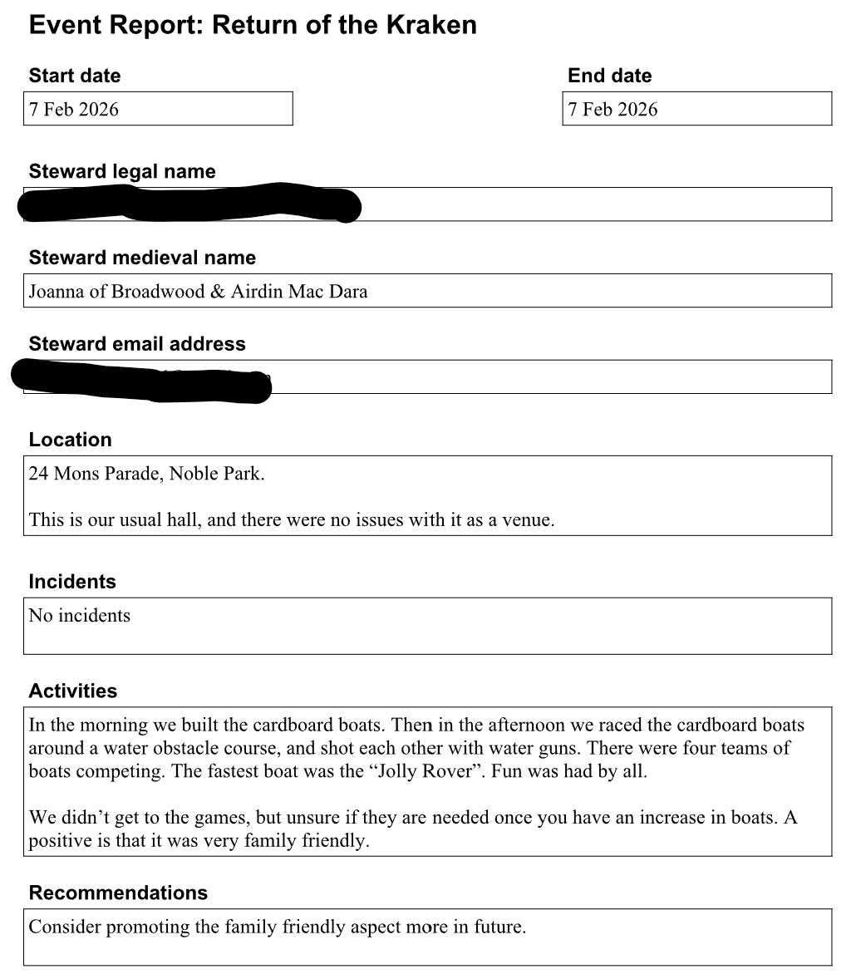

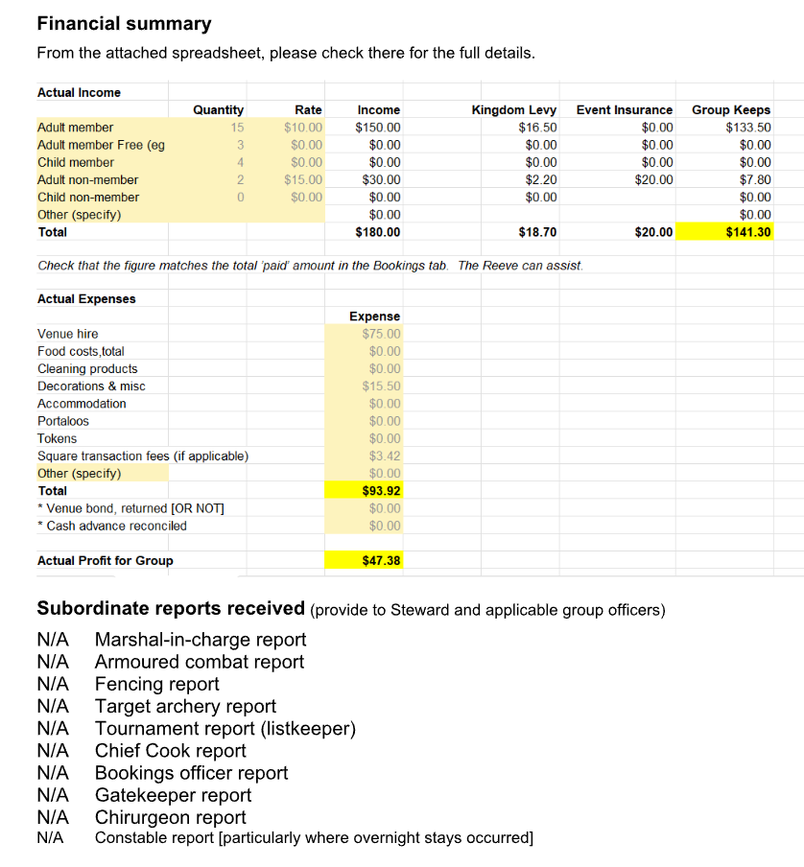

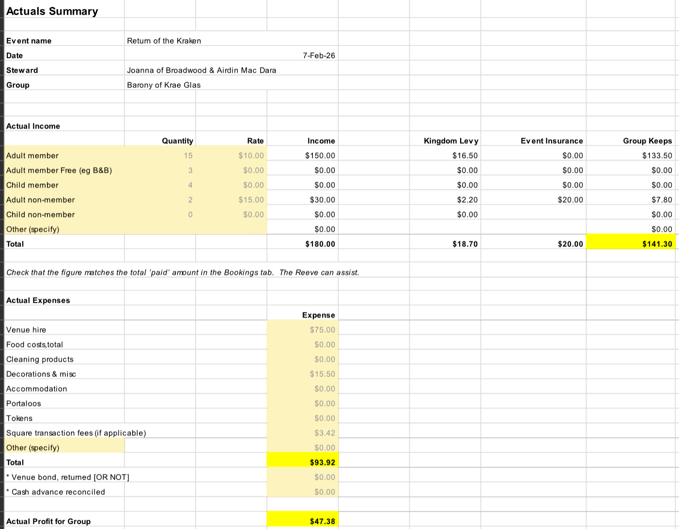

Appendix 2: Renfair Event Proposal (as amended and approved by Council)
