Barony of Krae Glas – Extraordinary Meeting for February
Date and time: 18th of February 2025
Attendees:
- Seneschal – Ysabel Norrice (Rebecca Taylor)
- Deputy Seneschal – Rúnfríðr (Rúna) Keiliselgr (Rachel Thorpe-Jones)
- Chronicler – Julia of the Ravens (Julia Jamieson)
- Deputy Reeve - Finn of St Monica (Finn Mac Eoin)
- Baroness – Margie of Glen More (Marg Henley)
- Populace attending – Airdin MacDara (Warren McArdle)
This extraordinary meeting was called primarily to approve the budget for Ides of March.
Minute taker: Rúna Keiliselgr

Motion:
Ysabel moved that we approve the budget for Ides of March. Finn seconded.
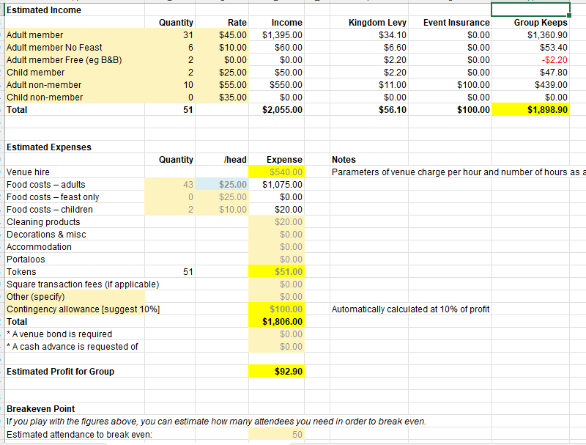
General business:
Ysabel has announced that she is going to be stepping down as Seneschal as it is no longer feasible for her to maintain her office given her move out west, continuing health obligations and caring responsibilities.
Rúna will become Acting Seneschal until the position can be advertised and a new candidate found.
Lots of thanks for Ysabel’s work over the time she was Seneschal.

