Barony of Krae Glas – Meeting Minutes January 2025

**Time:** opened by Rúnfríðr Keiliselgr at 7:42pm, closed at 9:07pm

**Date:** 21st January 2025

**Attendance:**

|  |  |  |
| --- | --- | --- |
| Seneschal | Ysabel Norrice (Rebecca Taylor) | Apologies |
| Deputy Seneschal | Rúnfríðr Keiliselgr  (Rachel Thorpe-Jones) | Present |
| Reeve | Elizabet Hunter  (Janet Coath) | Apologies |
| Deputy Reeve | Finn of St Monica  (Finn Mac Eoin) | Present |
| Knight Marshal | Muireach Mac Gréine (Andrew Wilson) | Present |
| Captain of Archers | Maude atte Weylete (Michelle Kurrle) | Apologies |
| Constable | Vacant – warrant expired in December | N/A |
| A&S Officer | Joanna of Braidwood (Joanna Thorpe-Jones) | Present |
| Deputy A&S Officer | Tassilon Fetherstonhaughe (Patrick Corby) | Present |
| Herald | Mærwynn of Legeceasterscire  (Maree Yarwood) | Present |
| Chatelaine | Hjortetakk Gorgonites (Asmodea Barton) | Apologies |
| Chronicler and Social Media Officer | Julia of the Ravens  (Julia Jamieson) | Present |
| Deputy Social Media Officer | Talie van Groeningen  (none) | Apologies |
| Quartermaster | Vacant – warrant expired in December | N/A |
| Webminister | 無名 of St Monica  (Kevin Duong) | Apologies |
| Baron | Jon Dai of the Lane (Stephen Davis) | Apologies |
| Baroness | Margie of Glen More  (Margie Henley) | Present |
| St Monica Seneschal | Theodwin Vriunt (Zachary Bessemer) | Apologies |

**Populace attending:** Roisin Cinnsealach (Leanne McArdle), Airdin Mac Dara (Warren McArdle), Robert Jamieson

**Minutes:** taken by Rúnfríðr Keiliselgr. Motions are in blue and action points in yellow.

**Previous minutes:** the minutes from the meeting from December 17th were approved. This was moved by Margie and seconded by Airdin. Carried unanimously.

Noted Theodwin’s warrant date is incorrect – change for next time.

**Officer appointments and vacancies:**

1. Deputy Reeve: Handover still to be completed between Finn and Elizabet with Finn then to take over the position of Reeve.
2. Herald: commentary period concluded for Ailbhe éccnaid (Ebony Biar) on the 14th of January. Ysabel and Maree with Crux to commence handover if the candidate successfully passed commentary.
3. Webminister: Kevin to stay on.
4. No applications for Constable or Quartermaster. Please encourage folks to go for it.

**Event reports:** none.

**Upcoming events:**

1. Already approved
   1. Battle on the High C’s stewarded by Airdin and Roisin on the 25th of January – cardboard boats, water and non-water activities
      * Update from Airdin: little interest and a lot has dried up over the break. There has been some confusion with the other nautical-themed event of High Tide. We will see if we can bring cardboard so people can make boats on the day.
      * Julia will be helping to promote. She noticed there hasn’t been much interacting or reach on the social media posts.
2. Pending approval
   1. Love: Fate vs Chance stewarded by Julia and Robert on the 15th of February
      * Agenda item: approval of budget. The Council approved up to $300 to be spent by the stewards and reimbursed by the Barony. Moved by Margie (Marg Henley) and seconded by Airdin (Warren McArdle). The budget is attached at the end of these minutes.
      * Maerwynn is available to herald
      * We need receipts for any expenditure.
   2. Ides of March stewarded by Rúnfríðr with Collegian support on the 15th of March
      * Update from Rúna: budget not ready to be submitted because we are still working out costs for the outdoor venue.
   3. Ironbeard Challenge stewarded by Maude and Jon on a date to be determined
      * Stewards not present, so no update on date.
3. Regular events
   1. Regular Thursday night training back on
   2. Bimonthly archery – postponed until autumn
   3. Crafthalls in Feb/Mar
      * Suggested by Margie: let’s have no communal meal at the end of Crafthall as we have other events in Feb with potlucks and don’t want to burn people out. Julia and Muireach agreed.
      * Craft lesson: tablet weaving, suggested by Finn. Margie happy to teach but doesn’t want to teach more than five or six at once. Set for March 8th.
      * Decided on no craft in February but a general theme of ‘welcome back, bring your stuff, planning day for the demo at Camelot Castle’ et cetera.
4. Other events
   1. Midsumma Pride March in collaboration with Stormhold and the College – 2nd of February
      * Update from Rúna generally on progress: the College is going fine with garb. Thank you to folks who are helping with that. We have no idea on the status of banner making if any.
      * Margie: I would like us to look like the SCA and use blue feathers as a symbol. Finn and Airdin will look for feathers at op shops and Cheap as Chips.
      * Suggestion that the Barony could fund it if cheap.
   2. Camelot Castle demo **–** 9th of February
      * Update from Robert: waiting to hear back from organisers re: whether they can meet our preferences for tables and space. The organiser has been on holidays. Will send a follow-up email this week and then ask for volunteers.
   3. High Tide: Tides of War run by Stormhold – 21st to 23rd of February in Altona, now a royal event
      * Margie: would be good to have attendant or two for court e.g. Theodwin.
   4. Chess Challenge on the 29th of March stewarded by a team including Dandelion, Erin and Miriam
   5. Rowany Festival on the 13th to 22nd of April
      * Update on Festival campsite: shared with Stormhold. Equipment hire now open, so we need to start planning. If anyone has ideas about food or being the warden or organiser for the camp, please tell Margie.
      * Officers generally unsure if they’re making Festival and who they’re camping with at the moment – Roisin’s work didn’t let her go because too many SCA people at her workplace are going to Festival ☹
      * Possible suggestion to put another call out on Facebook

**Outstanding business raised at previous meetings (if no updates, please refer to previous minutes):**

1. Fixing Baronial thrones – no update from last month
2. Award tokens – should no longer be on minutes
3. Baronial tokens – alright for tokens for now. Robert will start playing around and experimenting with the Choris Homeri within the next month or when he can. He and Margie will discuss it privately and in particular more images of the tokens from different angles would be good.
4. Membership in the hills region – Rúna noted the market is closed for stallholders. Finn to look into for demo. Various suggestions given including double list field, people with cards or info to hand out, static display of A&S, active fighting and dancing.
5. Hall updates from Airdin
   1. Issue with getting it mowed, received $150 invoice to do it without notice outside normal schedule as specified in contract. Frustrating and never a problem in the past. Airdin will ask for regular mowing schedule.
   2. Margie (Marg Henley) moved to approve the $150 expense to the Scouts for mowing the lawn. Roisin (Leanne McArdle) seconded.
   3. Michael is hoping to cheaply source plywood for the ramp and to have it finished by the end of February. Usual person doing it away for all of January. We will need to check it’s not too slippery.
   4. If someone can find a new hall, let us know. Scouts are getting more picky.

**New general business:**

**Autonomy of the Barony – item suggested by Margie:**

Margie: I cannot see that we are doing anything differently from Stormhold at the moment, but I won’t suggest that consolidating into one Victorian group is any solution to our current retention problems. Note the College seems more involved with Stormhold.

On the College’s involvement with Stormhold:

* Roisin: ex-Collegians are holding office. Margie is encouraged by this.
* Finn noted most of the Stormhold B&B kids are young, so there’s a connection there.
* Rúna doesn’t believe there’s evidence for the College being more involved with Stormhold and the numbers involved with either Barony regularly are small anyway.
* Margie: why did Stormhold book Pride instead of us and we weren’t approached?
  + Rúna notes that Nicolette, their Seneschal, responded before Krae Glas to the College request.

On communication with Stormhold:

* Margie: there have been scheduling conflicts and we need to communicate better both ways. This seems to be a more recent problem.
* Roisin: we often check for clashes, but I’m unsure whether they do.
* Finn queries whether having a dedication liaison officer would help. Airdin suggested the open chat with the Victorian B&Bs and Seneschals could be used more.

Rúna queried whether Margie’s original discussion intended to open up identity questions:

* Margie: yes. Gave history of Victorian groups and what made them different e.g. Krae Glas was service-oriented and had more families, Stormhold was longer-established and had older members and strong A&S, Arrowsreach did a lot of martial activities.
  + Julia: Arrowsreach used to cause and participate in a lot of shenanigans!
* Finn and Airdin suggested building identity by polling members and responding to what they want. Margie pointed out the B&B have been pushing for feedback ever since they were elevated and aren’t getting much.
* Roisin: is the geographical spread of Stormhold different?
  + Margie: they have a bigger area? Unsure how many are inactive.

Joanna noted the big difference between the Baronies in her mind is the College.

On the College:

* Joanna: where would the College go without the Barony nearby?
* Airdin: we need to discuss pathways into Barony. Finn noted Rúna has been pushing that within the College and calls it a ‘bottleneck’.
* Roisin: recent ex-Collegians should help tell the Barony what they need.
* Julia: after talking with Collegians (Tassilon, Joanna, Rúna) at Day of Honour, had idea of Barony members invading College nights every month?
  + Tassilon: always need Barony teachers.
  + Finn: also Barony participants, so Barony folks not always in position of authority.
  + Margie queried whether we could run events at or with the College.
  + Airdin noted Barony members can help Collegians with finances or lifts. Finn noted stronger ties would encourage Collegians to seek and accept help.
  + Margie: B&B would be thrilled to get recommendations for Baronial awards for Collegians.

**Officer reports that Rúna has access to:**

Reeve (Elizabet):   
Account balances as at the end of December 2024:  
Community Solutions One account $13,062.86   
Cash Reserve B account $0.01  
 For a total of $13,062.87   
No cash reserve or floats are outstanding. Xero fully reconciled to end of December 2024. Dropbox is up to date with bank statements and sign in sheets. No event reports outstanding. All is well, your Reeve is happy. Monthly, quarterly and Doomsday reports all complete.

Chronicler and Social Media Officer (Julia):

Chronicler: No newsletter this month. Mundane life got in the way.   
  
Social Media Officer:   
Stats: Facebook is at 227 likes & 242 277 followers (+34/35 from last month)! Insta is at 77 followers (+8 from last month)! Instagram's engagement rate is good, Facebook's engagement rate is excellent.   
  
My thoughts: We've actually lost a couple of obvious-bot followers on Instagram (yes, I notice these & they usually only last a couple of months before disappearing), so our "genuine followers" have actually gone up even more! It was brought to my attention recently that many Collegians are unaware that we are on Instagram as well as Facebook (posting the same things), so I might need to get Talie to mention our IG on Discord so that more collegians know about it.   
  
A few of our new followers are from overseas, but they all seem to be interested in re-enactment, so I'm happy to have them! A decent chunk of our new FB followers have their location listed as overseas, but I don't really have a way to tell if they're actually overseas, recent migrants who haven't updated their location, genuinely interested, bots or whatever. Any growth is good though & over 70% of our followers are listed as being in Aus. I don't check that stat regularly, but I think that percentage hasn't changed too much from when I last saw it, so it's not anything I'm concerned by.   
  
Engagement rates are based on the percentage of your followers who interact, so the fact that it's still really good even with the boost in new followers, is a great sign! That said, our engagement (both on FB & IG), mostly from the same people (yes I notice & yes, I love you for it 💜).   
  
Talie is doing a great job posting everything over to Discord & that's where most collegians are getting info from us.

College should advertise Barony Instagram.

B&B (Margie and Jon):

We have done little this month due to slow time over festive season. We sent a Season’s message to our populace via email List and Facebook posts to barony and college. Have asked for interest in being campsite steward for festival camp site. Looking forward to revised designs for baronial cloaks. Missing embroidery pieces have not been found. Thank you to Mistress Elspeth for reviving this project and donating base fabric. We are looking forward to upcoming events in our own Barony. If we are to survive as a barony we need to be running our own events and our members not just piggy packing on activities in neighbouring groups. We need to communicate with Stormhold so our activities do not clash. What can we do to encourage our populace and collegians so they are active members of Krae Glas rather than active participants in Stormhold?

Airdin asked if the College has Barony business cards. Rúna said no, as the College doesn’t get many non-uni aged people.

A&S Officer (Joanna):

Nothing to report.

College Seneschal (Theodwin):

Quiet lately. No support needed for O-Week currently in the last week of February but we’ll let the Barony know if this changes.

We have received a media request from a journalist (Lauren Ironmonger with *The Age/Sydney Morning Herald)* – has this also been received by Krae Glas?

Answer: Julia is unsure. Ask Asmodea or Ysabel.

Knight Marshal (Muireach):

Four people at the first training back! Airdin reported. Muireach wasn’t there.

Airdin noted there was a discussion of cost and if it went up due to not covering hiring of hall, whether people would pay $10. Discussion on Dolphin’s Keep page to be started by Airdin. Could have $5 for spectators, Collegians/concession?

Muireach: discussion on Thursdays as well? The most active people will turn up then.

Herald (Maerwynn):

Nothing to report other than commentary for successor may be still open? Haven’t heard anything.

Rúna: commentary closed on the 14th of January.

**Next reporting dates:** 1st of February – all Barony officers to their uplines and Ysabel.

The College quarterly reports should all have been handed in. Please acknowledge them.

The meeting was closed at 9:07pm.

People who stuck around got to see Rúna’s household’s cardboard boat making in progress.

**Action List:**

* Finn and Elizabet: handover to be completed for Finn to become Reeve (ongoing).
* Ysabel and Maree: assess commentary and commence handover for Herald if candidate was successful.
* Anyone and stewards: try to bring cardboard for High C’s this weekend.
* Julia: help promote High C’s event on social media.
* Rúna: finish budget for Ides of March.
* Maude and Jon: decide on Ironbeard date when they can.
* Margie, Julia, Joanna etc.: sort out logistics and promotion for March crafthall’s tablet weaving class.
* Finn and Airdin: source blue feathers for Pride.
* Robert: send follow-up email if Camelot Castle organisers still don’t respond this week.
* Anyone: if ideas about food or Festival campsite, tell Margie.
* Robert: start experimenting with Choris Homeri tokens when he has time.
* Finn: look into feasibility of hills area to hold demo.
* Airdin: ask for regular mowing schedule of hall.
* Ysabel and Rúna among others: communicate ahead of time of planned but not approved events on Victorian B&B and Seneschals chat? Otherwise, everyone to continue to communicate with Stormhold and check for event clashes.
* Rúna: communicate to the College query about feasibility of having Barony members over at specific nights e.g. once a month. Also ask Theodwin to promote Barony Instagram and ask Ysabel or Asmodea whether they also received the interview request from the journalist.
* All Barony officers: hand in reports by 1st of February to Kingdom upline and Ysabel.

**Love: Fate vs Chance Budget**

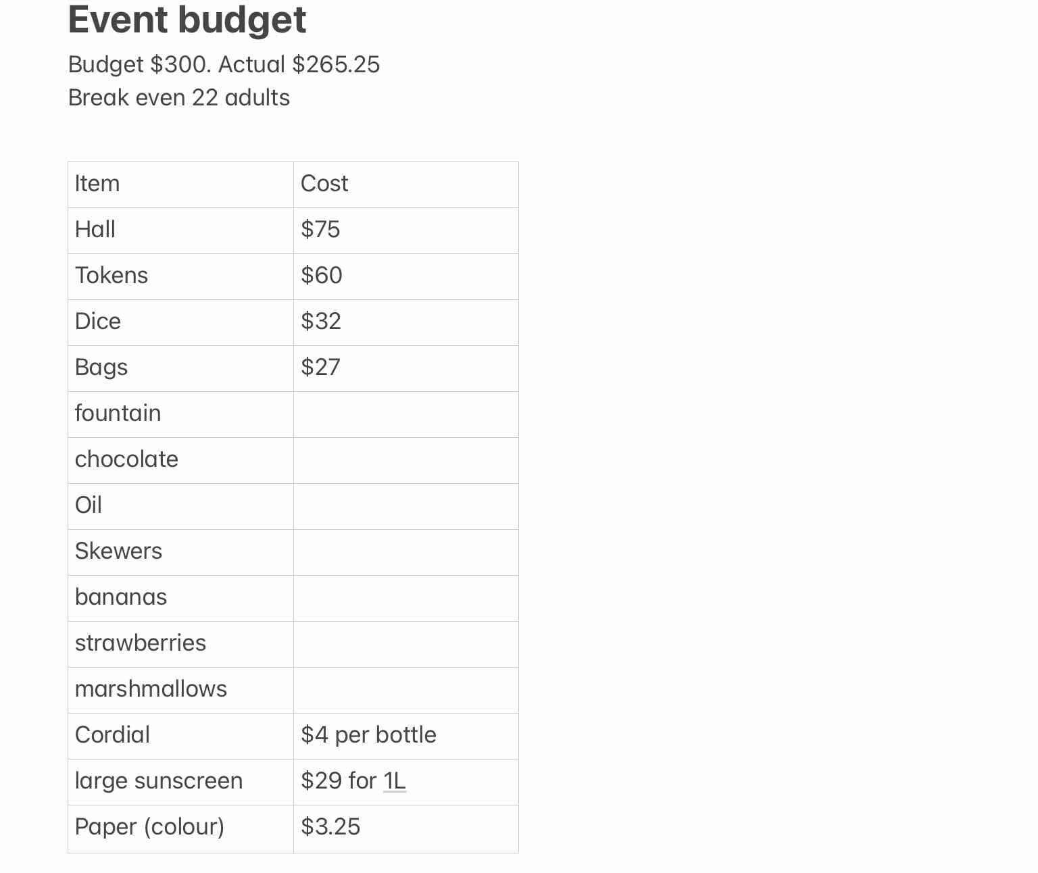

(Typo: actuals probably $266.25 – Rúna)